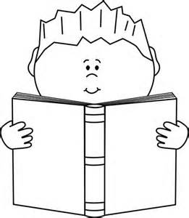
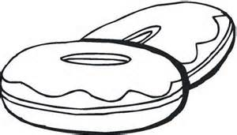

Book Fair: Parents and Pastries Event
When: Wednesday, March 25th (Early Release Day)
Time: 12:25 pm – 3:45 pm
Where: Crestwood Elementary School Library
What: Come to shop our book fair with your student as you enjoy free pastries and snacks.
Details: Please follow the regular Early Release Day transportation protocols. After you have picked up your student, you can come in through the office with your student to sign in for the event!
Who: All students are welcome to come with a loved one. All students will need to be accompanied by an adult.
If you have any questions please contact our Library Media Specialist, Kayla Thurman at kayla.thurman@oldham.kyschools.us.
------------------------------------------------------------------------------------------------
If you are going to attend this event, please complete this form and return to your student’s teacher by Monday, March 23rd.
Student Name_____________________ # of guests to attend________

